Iterated Conditional Modes for Image Denoising
PRML Page. 389 Markov Random Fields

For binary images, we minimize an energy function below,
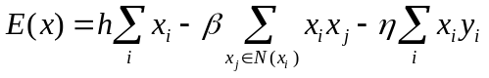
While for gray scale images, we minimize the following energy function,
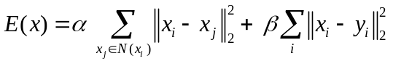
Where 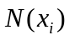 denotes the neighbors of .

